Lab 20: Mongo relationships practice

Information School, University of Wisconsin-Madison

**Deliverables:** This word document with questions answered uploaded to Canvas.

**Description**: This lab allows you to practice how to Practice uploading the example JSON document to Mongo Atlas

This lab assumes that you have done the following:

1. Set up a free Mongo Atlas account
2. You can use the Atlas interface or the Compass interface, or you can hand code.

# **Task 1: Practice implementing 1:M relationships**

***Painter Table***

|  |  |  |
| --- | --- | --- |
| ***PainterID*** | ***PainterLName*** | ***PainterFName*** |
| 1 | Picasso | Pablo |
| 2 | Monet | Claude |
| 3 | Warhol | Andy |

***Painting Table***

|  |  |  |  |
| --- | --- | --- | --- |
| ***PaintingID*** | ***PainterID*** | ***PaintingTitle*** | ***PaintingYear*** |
| 1 | 1 | The Old Guitarist | 1904 |
| 2 | 1 | The Weeping Woman | 1937 |
| 3 | 2 | The Water Lily Pond | 1899 |
| 4 | 2 | Woman with a Parasol | 1875 |
| 5 | 3 | Shot Marilyns | 1964 |
| 6 | 3 | Campbell’s Soup Cans | 1962 |

Task 1.1: Create the above in a JSON document using a simple array approach where artist is the main document and painting information for each artist is listed using array(s).

Task 1.2: Create the above in a JSON document using a subdocument approach where artist is the main document and each artist’s painting is in a named subdocument.

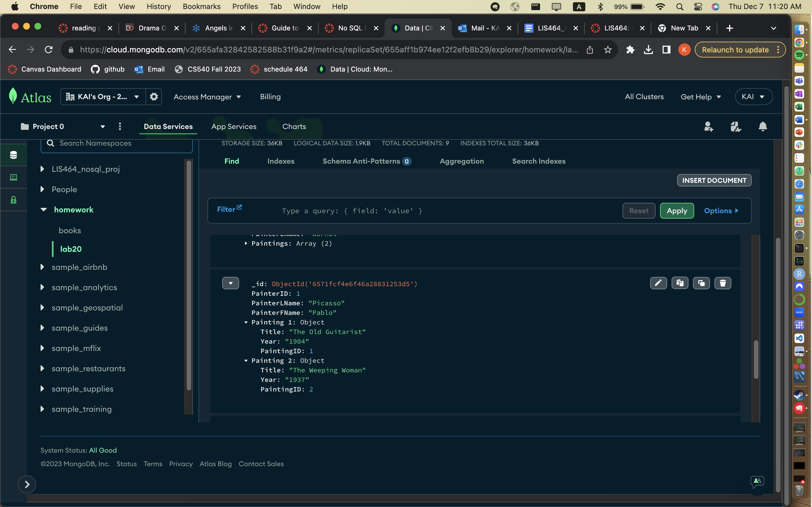

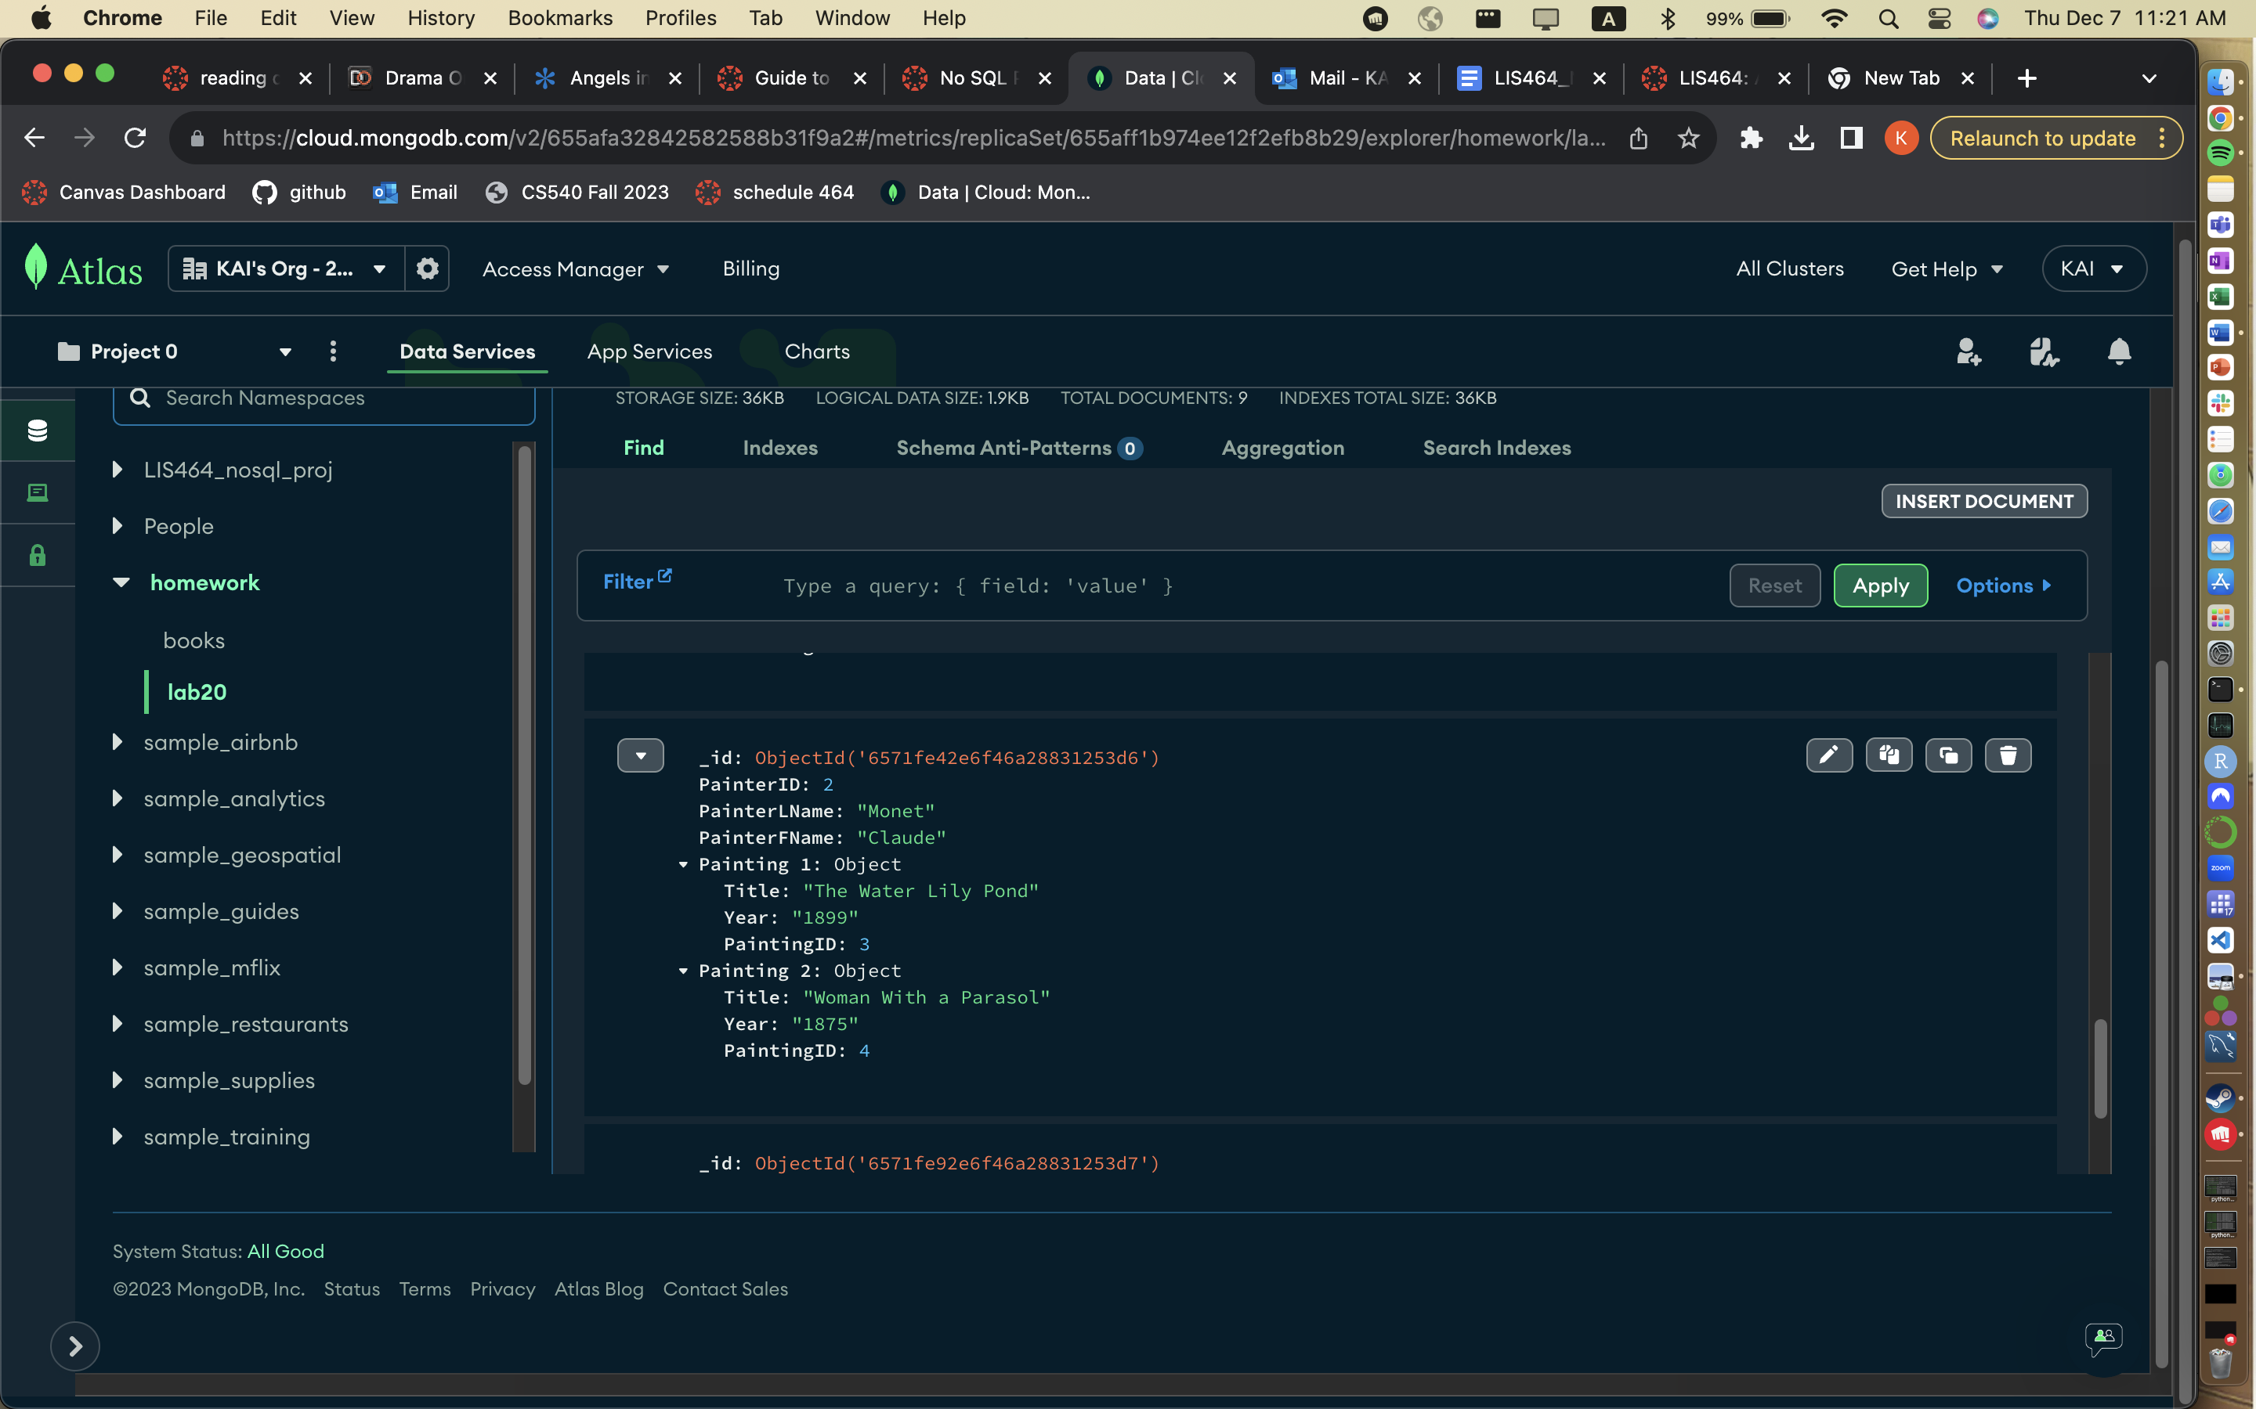

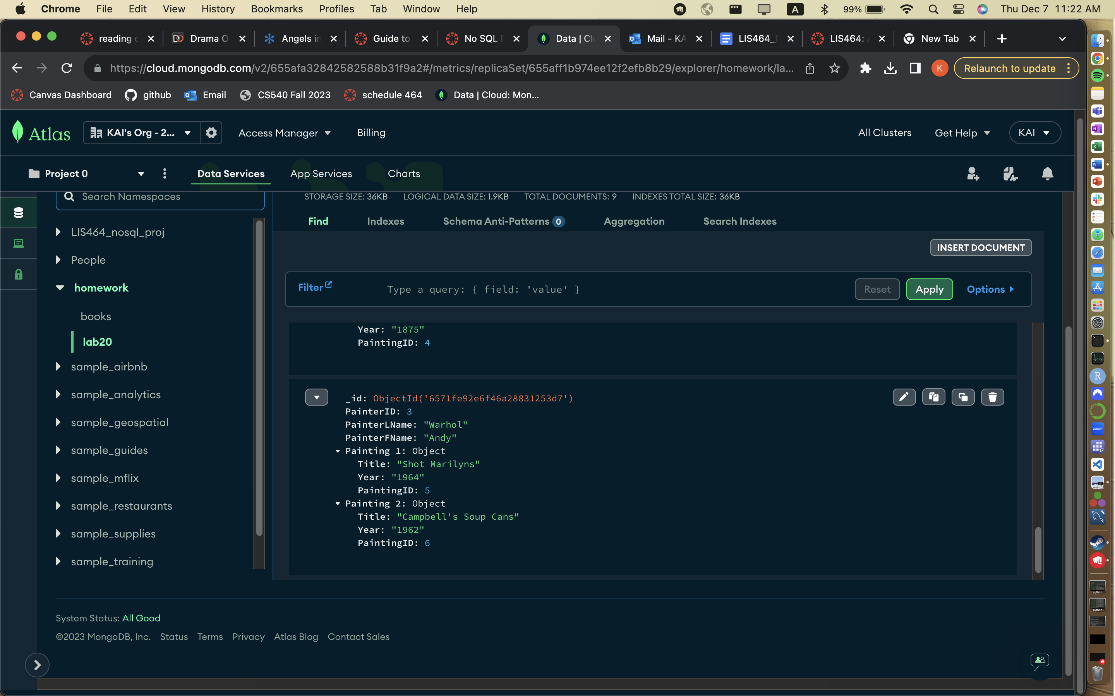

Task 1.3 Create the above in a JSON document using the subdocument-in-an-array approach where artist in the main document and each artist’s painting is in a subdocument in an array.

**

